Creating Citations on a Word Document

- On the References tab, in the Citations & Bibliography group, click the arrow next to Style.
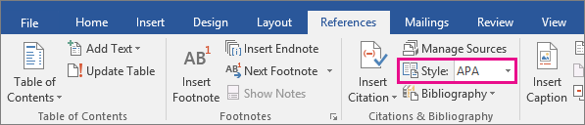
- Click the style that you want to use for the citation and source. (MLA for this class)
- Click at the end of the sentence or phrase that you want to cite.
- Click Insert Citation and then select Add New Source.
- In the Create Source box, type in the citation details, and then click OK.
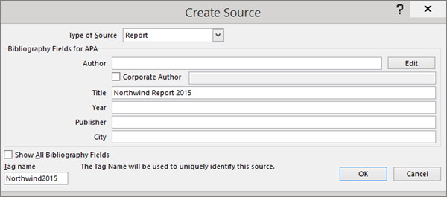
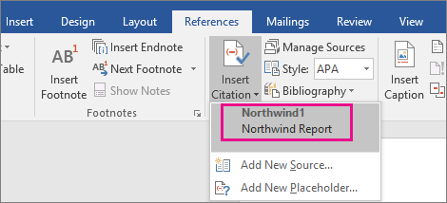
When you've completed these steps, the citation is added to the list of available citations. The next time you quote this reference, you don't have to type it all out again, just click References tab > Citations & Bibliography box > Insert Citation button and select the citation you want to use.

Create a bibliography from your sources
If you want to create a bibliography from your sources, do the following:
- On the References tab, in the Citations & Bibliography group, click Manage Sources.

- Make sure to move all sources you are citing are moved from the left column to the right side – you can do this by selecting the source and clicking the Copy button between the two columns.

- Once you have moved the sources to the right column, click close.

- To create the bibliography, first make sure your curser is on the last page

- go to the Reference tab > Citations & Bibliography box > bibliography drop box > and choose the style you would like

